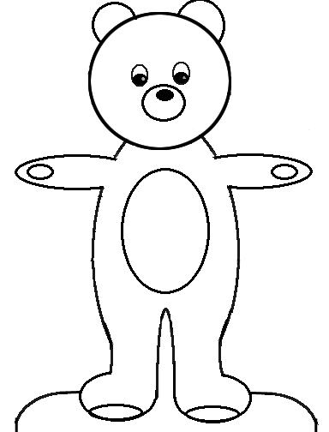
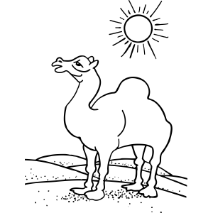
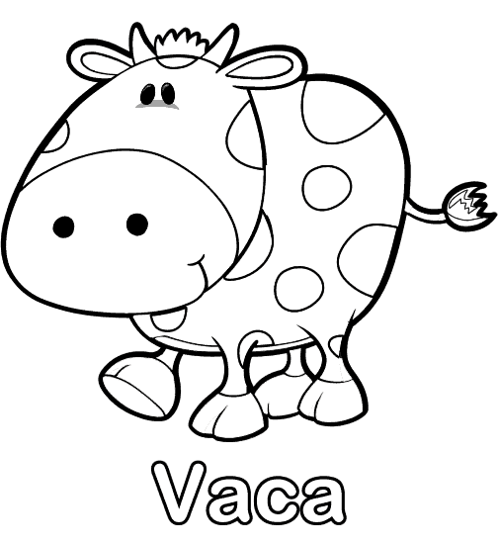
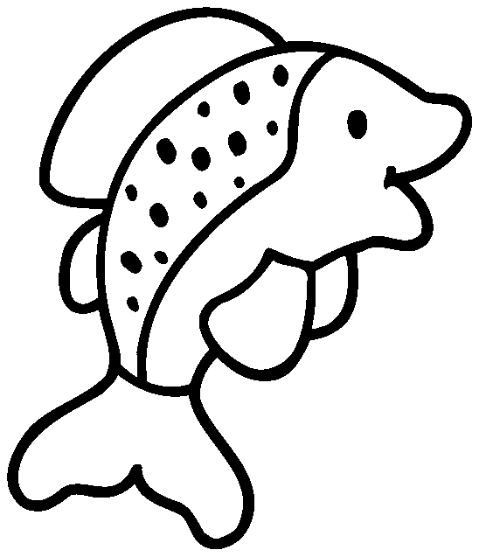
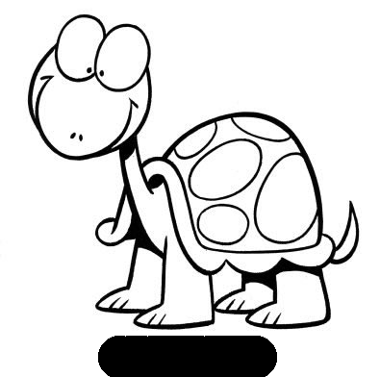
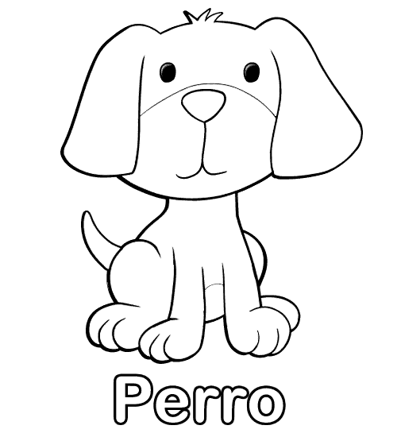
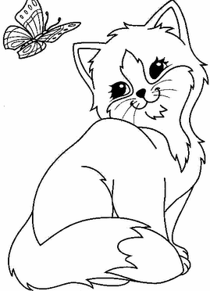
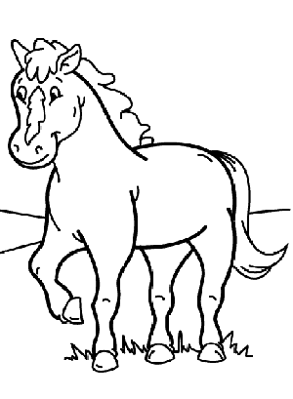
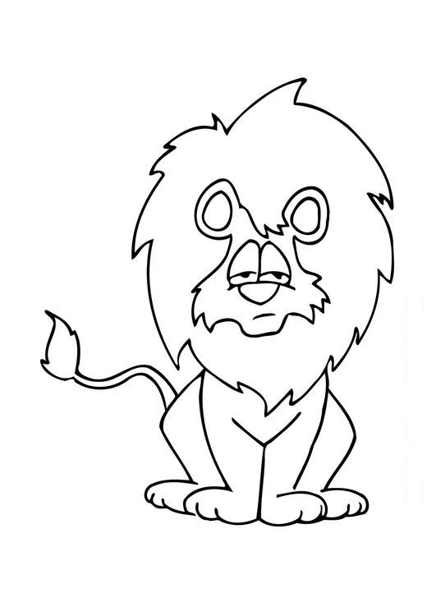
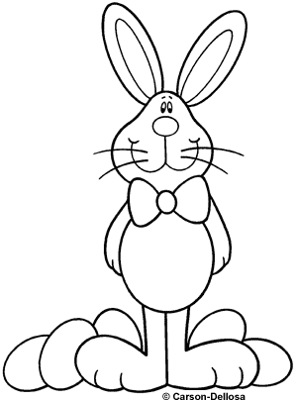
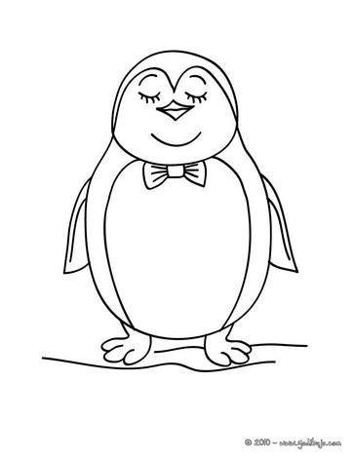
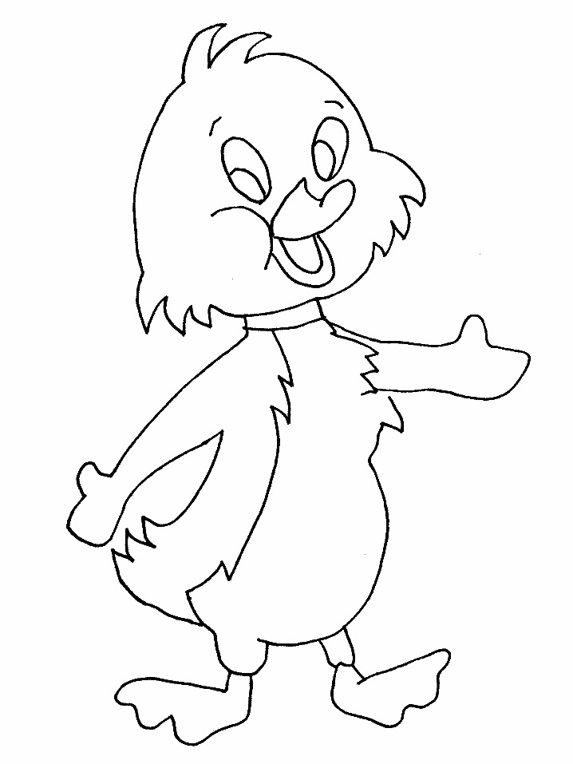
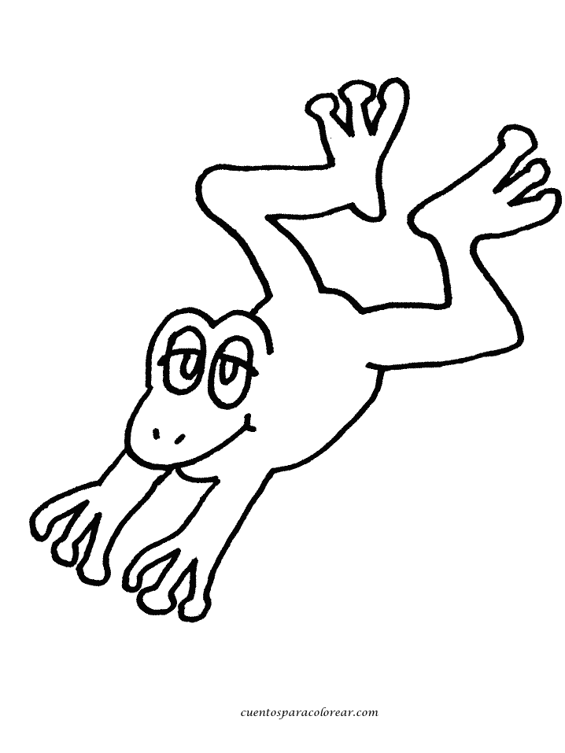

ACTIVITIES
I. Find ten (10) animals in the Word search.
G | H | Y | U | Q | C | O | W | A | E | R | D
G | D | O | G | N | M | Ñ | Z | X | T | Y | U
U | T | I | O | Ñ | F | I | S | H | B | E | C
F | R | O | G | Z | X | V | T | T | U | I | K
Q | D | T | U | M | K | L | F | B | L | Ñ | O
V | B | N | C | A | T | Z | X | C | I | E | H
T | U | R | T | L | E | B | N | Z | O | X | O
Q | R | Y | U | M | K | L | S | X | N | H | R
R | A | B | B | I | T | P | Ñ | Y | V | X | S
F | Y | U | B | Ñ | K | Z | X | Q | G | T | E

II. WRITE THE NAME OF THESE ANIMALS.

III. MATCH THE PICTURE AND THE NAME.
RABBIT
DUCK
FISH
CAT
BEAR

